**Gardening at Home Made Simple**

**The Joy of Caring for Plants at Home**

The lush green hues of plants bring vitality to your home, creating a harmonious aesthetic while refreshing the indoor atmosphere. This enhanced space not only promotes a closer connection to nature but also brings daily joy to plant lovers.

In modern living environments filled with electronic devices, your home may contain harmful substances in the air, such as toxins and heavy metals, which can adversely affect your health.

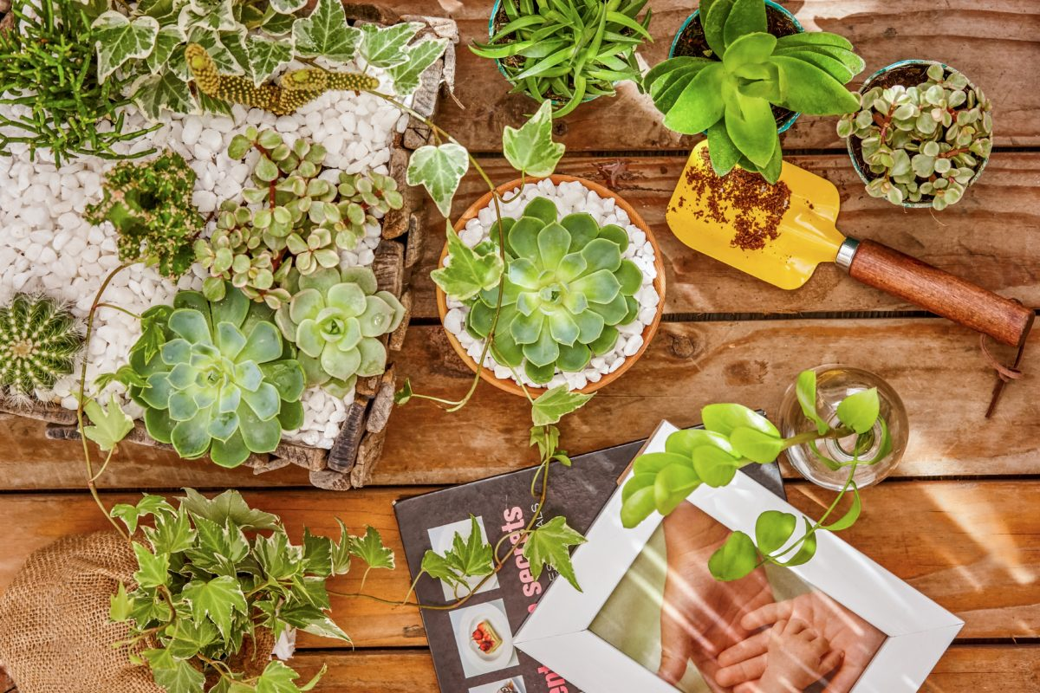

Introducing greenery into your home helps purify the air to some extent. Many air-filtering plants, such as Peace Lilies, Anthuriums, Ferns, Philodendrons, Pennyworts, Bromeliads, and Lavender, are readily available at flower shops.

Caring for these plants is surprisingly simple. Indoor plants can thrive in spaces with sunlight or even just artificial lighting. For example, place an Anthurium pot in the kitchen or a Peace Lily near the staircase.

Position a Fern by the fish tank alongside Pennyworts. In the living room, a Philodendron or Calathea pot adds charm to the coffee table.

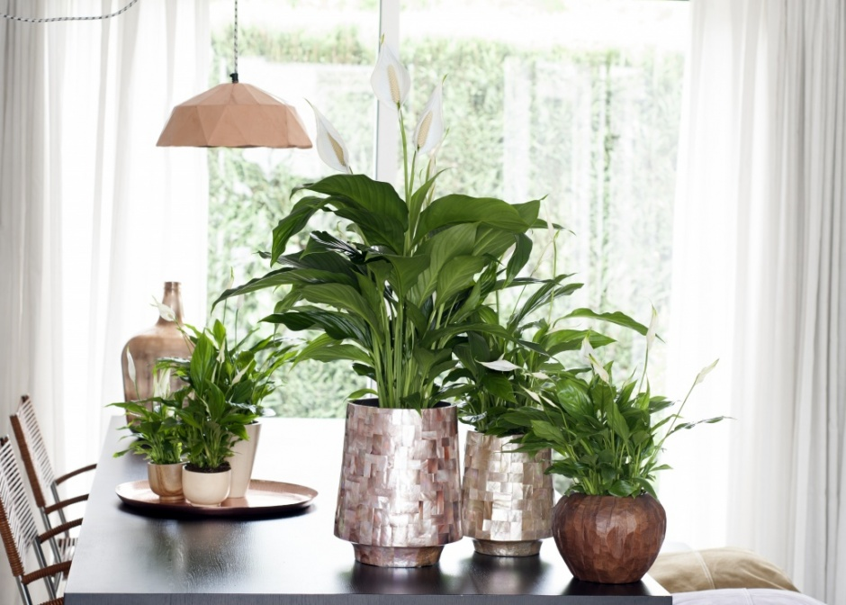

Spending time tending to indoor plants also doubles as a relaxing activity. It allows you to immerse yourself in nature right within your beloved home. For many, caring for plants becomes a therapeutic hobby, helping to alleviate mental fatigue, boost mood, and bring joy.

The green hues of foliage are known to ease stress and reduce eye strain. They create a sense of calm, comfort, and a refreshing coolness unmatched by other colors.

**Design Your Own Mini Garden**

If your home has a garden or balcony, it’s easy to create a personal green space. Imagine spending a weekend morning with your family, digging soil, planting flowers, and trimming leaves—such moments can become cherished memories, especially for children.

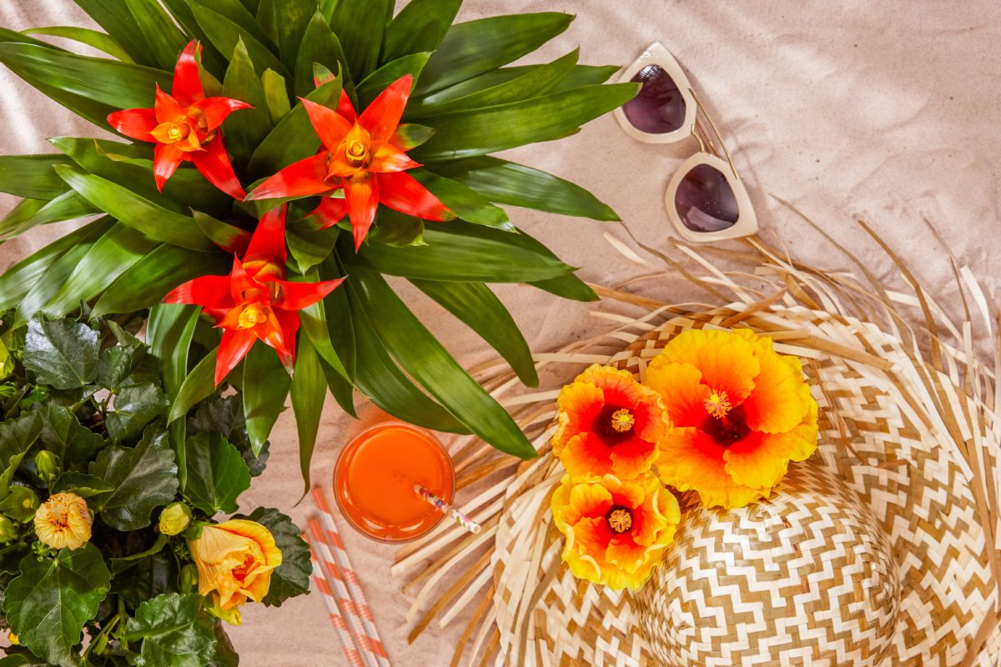

A sunny balcony is a blessing, making flower planting and care much simpler. Repurpose items like foam boxes or wooden crates from your home, add clean soil, and voilà! You have a cozy spot for planting charming flowers.

Hang pots of Petunias, Million Bells, or Jasmine on your balcony to let vibrant floral cascades sway in the breeze. In planters, grow colorful blooms like Daisies, Hydrangeas, Roses, Kalanchoes, and Forget-Me-Nots to create a vibrant, multi-hued garden.

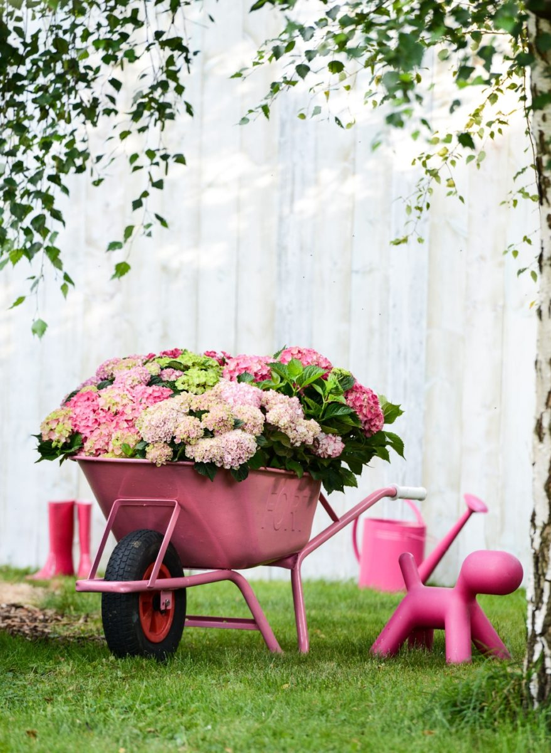

For those fortunate enough to have a small garden, consider planting flowers in rows along pathways. Don’t worry about fertilizers; clean soil is often enriched with nutrients that sustain plant growth for extended periods. This type of soil is typically derived from post-harvest flower stems and leaves, enhanced with beneficial microorganisms and fungi to eliminate harmful bacteria while boosting fertility.

Besides cultivating flowers, planting vegetables is another rewarding option. Clean soil is ideal for growing leafy greens, herbs, and root crops like radishes or strawberries. These additions not only bring life to your home but also provide fresh produce for your daily meals. Moreover, gardening can encourage children to unplug from electronic devices and engage in a hands-on, family-friendly activity.

**Getting Started**

Begin your gardening journey by visiting a flower shop. Choose pots of flowers you love—those with air-purifying properties and vibrant colors. With your family, design a small, diverse garden that adds a burst of life and color to your living space.